Order Summary

Path : Reports >> Sales Summary.
Steps to reach Sales Summary:
Step 1 : Reports in Steps to reach Sales Summary : Open the Reports module from the Billing Application(POS) .
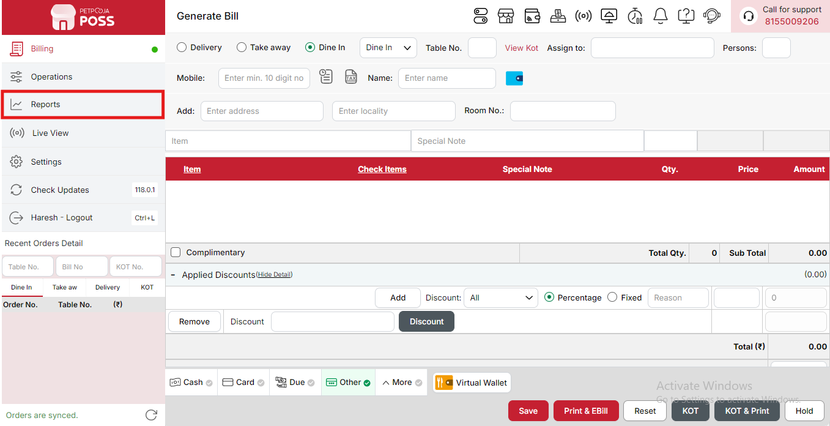
{Image Name: Reports Option,
Description: The red box highlights the “Reports” option in the sidebar menu. This section allows users to view and analyze various business reports, such as sales, billing, and order summaries, helping in effective tracking and decision-making.Here is an image of Step 1 Report in Steps to Reach Order Summary.}
Step 2 : Sales Summary in Steps to reach Sales Summary : Select Sales Summary to view an overview of total sales, including item-wise and category-wise performance, revenue, and discounts applied.
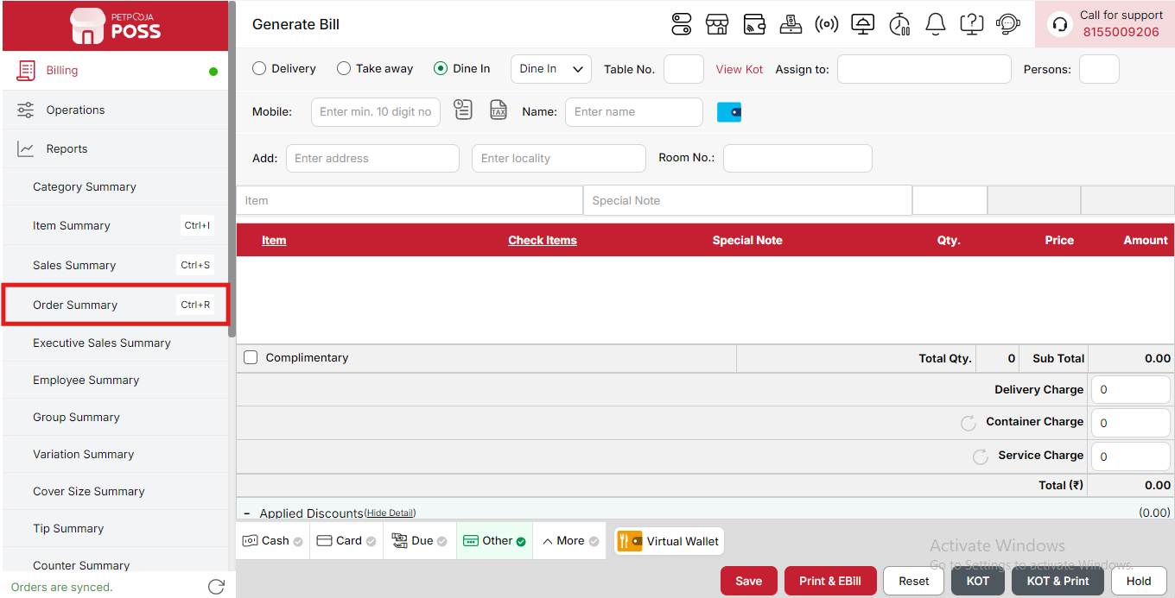
{Image Name: Order Summary,
Description: The red box highlights the Order Summary option in the Reports menu. This section provides a detailed overview of all customer orders, including order status, quantities, and totals.Here is an image of Step 2 Order Summary in Steps to Reach Order Summary.}

Key features of Order Summary :
(Order Summary) Note: If you are not able to see or use the Order Summary option in your billing application, it means that you do not have the required permission. To enable this, you need to go to the Owner Dashboard and open the User Management section. Inside User Management, you will find a permission called Order Summary Show Button — you must checkmark this option to give access.If you are not able to view old day reports, then you also need to enable the Days Restriction permission. Inside the same User Management section, select No Restriction so that you can view reports for any date.After allowing these permissions, perform a manual sync so the system updates the rights properly. Once the sync is done, log out from the billing application and then log in again. After this process, the Order Summary option will become visible, and you will be able to view all reports without any problem.
- (Order Summary) Order Summary Report - [Date]: Shows a summary of all orders made on the selected date, helping track daily sales and performance. It gives a quick view of how many orders were saved, printed, cancelled, or returned on that day.
- (Order Summary) Order Status: Displays the current stage of each order, such as Saved, Printed, Cancelled, etc. It helps to understand the progress of orders and how many are completed or still pending.
- (Order Summary) Saved: Shows orders that are saved but not yet finalized or printed. These are pending orders waiting for confirmation or completion before billing.
- (Order Summary) Printed: Displays all completed and printed orders counted as final sales. This shows the total number of successful bills generated during the day.
- (Order Summary) Cancelled: Shows orders that were cancelled before completion or billing. It helps to identify how many transactions were stopped or removed during the process.
- (Order Summary) Complimentary: Displays free or promotional orders given to staff or customers. This helps track items or services offered without charge for promotions or goodwill.
- (Order Summary) Sales Return: Shows products or orders returned by customers after billing. It helps to monitor refunds and maintain accurate stock and sales records.
- (Order Summary) Total: Displays the total amount and number of all orders for that day. It gives the final summary of overall sales, cancellations, and returns.
- (Order Summary) Success Orders (44): Shows the total number of successfully completed orders for the day. It helps track how many transactions were finalized without cancellation or issues.
- (Order Summary) Cash: Represents orders paid directly with cash. This helps monitor the physical money collected during the day.
- (Order Summary) Card: Refers to payments made using debit or credit cards. It helps track electronic transactions through POS systems.
- (Order Summary) Due Payment: Indicates pending payments that are recorded but not yet received. Useful for tracking outstanding customer dues.
- (Order Summary) Other: Represents payments received through third-party delivery platforms. It helps account for external service integrations.
- (Order Summary) Wallet [Virtual]: Refers to payments made via digital wallets or virtual payment apps. It helps track cashless transactions.
- (Order Summary) Online Orders: Shows payments received from online sales or digital order channels. Useful for understanding the online sales contribution.
- (Order Summary) Total: Displays the overall total of all successful orders and payments combined for the day. It gives a complete view of total daily revenue.
- (Order Summary) Cancelled Orders (1): Shows the number of orders that were cancelled before completion. Helps track order cancellations for analysis and reporting.
- (Order Summary) Payment Type: Shows different modes through which payments were received. Helps track how customers are paying for their orders.
- (Order Summary) Cash: Represents payments made directly in cash. Useful for tracking physical money collected during the day.
- (Order Summary) Card: Refers to payments made using debit or credit cards. Helps monitor electronic payments through POS systems.
- (Order Summary) Due Payment: Indicates payments that are pending and yet to be received from customers. Useful for managing outstanding balances.
- (Order Summary) Other: Represents any payments made through alternative methods or platforms not listed separately.
- (Order Summary) Wallet: Refers to payments made using digital or virtual wallets. Helps track cashless transactions via payment apps.
- (Order Summary) Online Orders: Shows payments received from online order sources or delivery platforms. Useful for tracking online sales.
- (Order Summary) Total: Displays the combined total of all payment methods for the day. Provides a complete view of total revenue collected.
- (Order Summary) Due Payment Received Summary: Displays details of payments collected against previously pending or due amounts. It helps track how much outstanding balance has been cleared.
- (Order Summary) Payment Type: Shows different methods used by customers to pay their pending dues.
- (Order Summary) Cash: Represents due payments that were received in cash. Useful for tracking cleared dues paid directly at the counter.
- (Order Summary) Card: Refers to due payments made through debit or credit card transactions. Helps track electronic receipts for pending bills.
- (Order Summary) Other: Indicates due payments received through third-party platforms such as delivery services. Useful for reconciling external partner transactions.
- (Order Summary) Total: Displays the combined total of all due payments received from various methods. Provides an overall view of recovered outstanding amounts.
- (Order Summary) Virtual Wallet Summary: Displays a summary of all transactions made through the virtual wallet. It helps track digital payments, top-ups, and withdrawals made using wallet balance.
- (Order Summary) Payment Type: Shows the different modes used for wallet-related payments, helping to understand how transactions are processed through virtual payment methods.
- (Order Summary) Expenses Summary: Provides details of all expenses recorded for the day. It helps monitor operational spending and track overall business expenses.
- (Order Summary) Withdrawal Summary: Shows records of any withdrawals made from the system or wallet. It helps track fund movements and maintain accurate balance management.
- (Order Summary) Cash Top-Up Summary: Displays details of cash added to the system or wallet for operational purposes. It helps ensure the availability of sufficient working funds.
- (Order Summary) Online Orders: Displays details of all orders placed through online platforms or websites. It helps track total online sales and order count.
- (Order Summary) Payment Type: Shows the modes of payment used for online orders, such as cash on delivery, online payment, or card. This helps analyze customer payment preferences.
- (Order Summary) Home Website - Show Brandwise: Allows viewing of online sales categorized by brand, helping identify which brands are performing better on the online platform.
- (Order Summary) Cash: Refers to orders paid in cash upon delivery or collection. It helps monitor offline payments related to online orders.
- (Order Summary) Online: Indicates payments made through online gateways or digital modes. It helps track digital transactions from online orders.
- (Order Summary) Sub Total: Displays the combined total of all online order payments before any adjustments or deductions.
- (Order Summary) Total: Shows the final calculated total of all online orders, providing a clear summary of online revenue.
- (Order Summary) Web Created Orders [Online Orders]: Represents orders that were directly created through the web or online system, helping track system-based order entries.
- (Order Summary) Order From: Displays the platforms or sources from which online orders originated, helping identify the primary sales channels.
- (Order Summary) Advance Order Summary: Shows information about advance payments received for future orders. It helps track pre-booked sales and deposits.
- (Order Summary) Advance Order (Invoice Summary): Provides a summary of invoices generated against advance payments. It helps monitor how many advance orders were billed.
- (Order Summary) Count: Represents the total number of advance order invoices created.
- (Order Summary) Today Received Amount: Shows the total amount received as advance payments on the selected date.
- (Order Summary) Total: Displays the cumulative total of all advance order payments and invoices for the day.
- (Order Summary) Advance Order (Memo Summary): Displays a summary of advance orders that have been recorded as memos before invoice generation. It helps track pending or pre-booked orders awaiting billing.
- (Order Summary) Count: Indicates the total number of advance order memos created during the selected period.
- (Order Summary) Cash: Represents advance payments received in cash for pre-booked orders. Helps track physical payments made in advance.
- (Order Summary) Card: Refers to advance payments received through debit or credit cards. Useful for tracking electronic advance transactions.
- (Order Summary) Other: Represents any other modes of payment used for advance bookings, such as digital wallets or third-party platforms.
- (Order Summary) Remaining: Shows the pending balance amount that is yet to be received for advance orders. Helps monitor incomplete payments.
- (Order Summary) Total: Displays the total value of all advance order memos, including received and pending amounts. Provides an overview of advance booking revenue.
- (Order Summary) Advance Order (Due Received Summary): Shows payments received for previously due advance orders. It helps track collection of outstanding amounts from earlier advance bookings.
(Order Report) Quick Search Option: Used to quickly see reports without selecting any date or filter.There are two options:
- Yesterday Sales – Shows the complete sales report for yesterday’s date directly.
- Today Sales – Shows the complete sales report for today’s date directly.
Search Button (Order Summary) : The Search button is used to find the report for a specific date or time. It helps you quickly see sales details for the selected period. After choosing the date or time, you can click on Search to view the report.
- From (Order Summary) : The From option is used to select the starting date for the order report. It means the report will begin from this date.
- To (Order Summary) : The To option is used to select the ending date for the order report. It means the report will show data up to this date.
- Order Type (Order Summary) : The Order Type option allows you to choose the type of orders you want to view in the report. You can select from Dine In, Delivery, or Pick Up to see the report for that specific order type within the selected date range.
- Time Wise Option (Order Summary) : The Time Wise Option is used when you want to see the report for a specific time period within a day. After turning it ON, you can choose both date and time — for example, from 10:00 AM to 5:00 PM — to see sales during that time. If you keep this option OFF (Without Time Wise Option), then the report will show the whole day’s data for the selected date range without filtering by time.
(Order Summary) Print Button: The Print Button is used to print the report. If you want to take a printout of the report, you just need to click on the Print button.
If you get an error saying “Please assign one printer for report print”, then follow these steps:
- Go to Operation → Bill/KOT Print → Multiple Printer Settings.
- Select and edit one printer that you want to use for printing the report.
- In that printer setting, there is an option called “Use this printer for report print”.
- Check this box and save the setting.
After doing this, you will be able to print the report successfully using the selected printer.
(Order Summary) Print Configuration: This section is used to set how your report will look when you print it. You can change the format, size, and what details to show on the printed page.
- (Print Configuration) Show Bill Header: If you check this option, the header (top part with company or shop name) will appear on the print.
- (Print Configuration) Show Bill Footer: If you check this option, the footer (bottom part with notes or messages) will appear on the printed report.
- (Print Configuration) NONE: Select this option if you don’t want to apply any specific print format or layout. The report will print in the default basic format without additional formatting or sections.
- (Print Configuration) Display To Date on Print: If you check this option, the “To Date” of the report will be shown on the printed page.
- (Print Configuration) Display Time on Print: If you check this option, the time will be displayed on the print along with the date.
- (Print Configuration) Display Summary Box on Print: If you check this option, a summary box will appear at the end of the report showing total amounts and other summary details.
- (Print Configuration) Display Print Date & Time on Print: If you check this option, the date and time when the report was printed will appear on the print.
- (Print Configuration) Main Width: Used to set the width of the report on the printed page. For example, 500 means the report will be printed with that width size.
- (Print Configuration) Font Size: Used to set the text size of the printed report. You can increase or decrease it as needed.
- (Print Configuration) Cancel: Click this button to close the print configuration window without saving any changes.
- (Print Configuration) Save:Click this button to save all the changes you made in the print configuration settings.
(Order Summary) Export Excel: If you want to download or save the report in Excel format, you have to click on the Export Excel button. This will create an Excel file of the report that you can open and use in Microsoft Excel.

